

**Department of Computer Science and Engineering**

**TECHNO INDIA NJR INSTITUTE OF TECHNOLOGY**

RAJASTHAN TECHNICAL UNIVERSITY ( RTU )

**May 2022**

**BuyOnlineBooks**

**A**

**Major Project Report**

*Submitted*

*In partial fulfilment*

*For the award of the Degree of*

**BACHELOR OF TECHNOLOGY**

***In Department of Computer science and Engineering***

**Submitted By: Submitted To:**

* Mr.Aditya Maheshwar
* Harshita Mehta(18etccs042)
* Pooja Dave(19etccs205)
* Payal Patel(18etccs070)
* Asha Yadav(18etccs012)

***ABSTRACT***

**1. Purpose**

**1.1. Introduction**

The main objective of the project is to create an online book store that allows users

to search and purchase a book online based on title, author and subject. The

selected books are displayed in a tabular format and the user can order their books

online through credit card payment or COD . Using this Website the user can purchase a

book online instead of going out to a book store and wasting time.

There are many online book stores. I would like to develop a similar website using

html, css, JavaScript, bootstrap 5, MySQL. Online Book store is an online web application

where the customer can purchase books online.

Through a web browser the customers can search for a book by its title or author, later can

add to the shopping cart and finally purchase using credit card transaction. The user can login using

his account details or new customers can set up an account very quickly. They should give the details

of their name, contact number and shipping address. The user can also give feedback to a book by

giving ratings on a score of five.

The Online Book Store Website provides customers with online shopping through a

web browser. A customer can, create, sign in to his account, place items into a shopping cart

and purchase using his credit card details. The Administrator will have additional functionalities

when compared to the ommon user. He can add, delete and update the book details, book categories,

member information and also confirm a placed order.

This application is developed using html, css, JavaScript, bootstrap 5, MySQL programming

language Apache Xampp.

***ACKNOWLEDGEMENT***

It gives me immense pleasure to express my deepest sense of gratitude and sincere thanks to

my highly respected and esteemed guide **Mr.Aditya Maheshwari TINJRIT** for their valuable

guidance, encouragement and help for completing this work.

Their useful suggestions for this whole work and co-operative behavior are sincerely

acknowledged. I would like to express my sincere thanks to **the HOD** of **CSE**

**TINJRIT** for giving me this opportunity to undertake this project.

I also wish to express my indebtedness to my parents as well as my family member

whose blessings and support always helped me to face the challenges ahead.

At the end I would like to express my sincere thanks to all my friends and others who helped

me directly or indirectly during this project work.



**CERTIFICATE**

**This is to certify that this project report “Online Examination System” is the confide work of**

**“Harshita Mehta, Pooja Dave, Asha Yadav, Payal Patel” who have carried out the project work under**

**my supervision. I approve this project for submission of the Bachelor of Technology in the**

**Department of Computer Science and Engineering, Techno India NJR Institute of Technology,**

**affiliated to Rajasthan Technical University, Kota.**

**Mr.Aditya Maheshwari**

**(Department of Computer Science)**

**TABLE OF CONTENTS**

Table of Contents

Abstract.................................................................................................................................................. 2

Acknowledgement ................................................................................................................................... 5

Certificate .............................................................................................................. .............................. 4

Table of Contents ...................................................................................................................................5-6

List of Tables ....................................................................................................................................... 7

List of Figures ........................................................................................................................................ 8

**CHAPTER – 1 Introduction .............................................................................................................. 9-12**

Introduction ............................................................................................................................................. 9

1.1.Purpose ............................................................................................................................................. 10

1.2.Overall Description ........................................................................................................................... 12

**CHAPTER – 2 Software Requirement Specification ..................................................................... 13-21**

2.1. Purpose............................................................................................................................................. 14

2.2. Overall Description ........................................................................................................................... 15

2.2.1. Functional Requirements definitions .............................................................................................. 16

2.2.2.Use Cases ...................................................................................................................................... 16-19

2.2.3.Non – Functional Requirements ................................................................................................... 20

2.3. Requirement Specification .............................................................................................................. 20

2.3.1. External interface specifications ................................................................................................... 20

2.3.2. Functional Requirements ............................................................................................................. 20

2.4. Hardware Specification ................................................................................................................... 20

2.5. Software Specification .................................................................................................................... 20

2.6. Hardware and Software Requirements in detail ............................................................................... 21

**CHAPTER – 3 System Analysis and Design ................................................................................ 22-28**

3.1.Study & Weaknesses of current system ........................................ ......................................................... 23

3.2 Requirements of new system ............................................................................................................ 23

3.3. Feasibility Study ............................................................................................................................. 23

3.4. Features of new System .................................................................................................................. 24

3.5. Data flow diagram .......................................................................................................................... 25-27

3.6. UML Modeling............................................................................................................................... 27

3.6.2. Class Diagram ............................................................................................................................. 28

**CHAPTER – 4 Data Dictionary ..................................................................................................... 29-32**

4.1. Table Details .................................................................................................................................. 30-31

4.2. E-R Diagram .................................................................................................................................. 31-32

**CHAPTER - 5 Screen Shots .......................................................................................................... 33-48**

5.1. Admin Panl …................................................................................................................................ 34-43

5.2. User Panel….................................................................................................................................... 44-46

5.3. Data base….................................................................................................................................... 47-48

**CHAPTER – 6 Conclusion and Future Enhancements ................................................................. 49-50**

7.1. Limitations ..................................................................................................................................... 50

7.2. Future Enhancements ...................................................................................................................... 50

7.3. Conclusion ..................................................................................................................................... 50

**CHAPTER – 7 Bibliography .............................................................................................................. 51-52sss**

**List of Tables**

|  |  |  |
| --- | --- | --- |
| **Table No.** | **Table Name** | **Page no.** |
| Table 4.1.1. | AdminLogin |  |
| Table 4.1.2. | Member table |  |
| Table 4.1.3. | Delivery boy table |  |

**List of Figures**

|  |  |  |
| --- | --- | --- |
| **Figure No.** | **Figure Name** | **Page no.** |
|  | **Use Case:** |  |
| 2.2.2a | Access Home Page |  |
| 2.2.2b | User Login or Signup |  |
| 2.2.2c | Admin Create login/Upload /delete |  |
| 2.2.2d | User choose Books, Purchase, sell/upload |  |
|  | **Data Flow Diagram :** |  |
| 3.5.1a | Zero level DFD |  |
| 3.5.1b | Level 1 DFD |  |
| 3.5.1c | Level2 DFD |  |
|  | **UML Diagram :** |  |
| 3.6.1. | Class diagram of Buy Online Book System |  |
|  | **ER Diagram :** |  |
| 4.2. | ER diagram of Buy Online Book System |  |

***CHAPTER – I***

***INTRODUCTION***

**Introduction**

**1.1. Purpose**

***1.1.1. Introduction***

* Our project is to create an ecommerce Website(BuyOnlineBooks).
* In this Website we can easily Buy or Sale your old or previous books or any other books, it helps us to find books related to any subject, it can be novels, autobiography etc.
* It’s a kind of Online library where, student can upload their last year or previous books or old books of different subjects.
* The books are easily available to all they can buy books online.
* This module provides the details of candidate who is providing books to others , where he can register himself and post available books, and access other books.

***1.1.2. Scope***

* This project in near future will provide facilities for generating online request and quick response for book access and upload for world wide users. In future time user can not only access books but also magazines, articles, writeups, short stories by upcoming authors and publishers.
* It will provide a best platform to those people who are beginners and want to develop their carrier in these fields.

***1.1.3. References***

* W3schools
* MyPustak.com

<https://mypustak.com/>

* openlibrary.org

<https://openlibrary.org/>

***1.1.4. Document overview***

The first providing introduction of the project. It lists all the functions performed by the system. The

second chapter consists of software requirements specification. The third chapter provides details about

system analysis and design. The fourth chapter gives data dictionary information. The fifth chapter consists

of snapshots of the complete project. The sixth chapter gives testing for the project. The seventh chapter tells

about the conclusion and future enhancements of the project. The final chapter concerns with the

bibliography.

This document is meant for describing all the features and procedures that were followed while

developing the system. This document specially mentions the details of the project how it was developed,

the primary requirement, as well as various features and functionalities of the project and the procedures

followed in achieving these objectives.

The main objective of website is to create a platform where user can access the books for reading,

purchasing, and selling over the world wide online itself and need not go out for that purpose.

**1.2. Overall description**

The online Book store is an online website where the customer or user can purchase, sell, read, or upload books online. Through a web browser the customers can search for a book by its title or author, later can add to the shopping cart and finally purchase using credit card transaction.

***1.2.1. Functional requirements definitions***

Functional Requirements are those that refer to the functionality of the website, i.e., what services it will provide to the user. Non-functional (supplementary) requirements pertain to other information needed to produce the appropriate system and are detailed separately.

***1.2.2. Use cases***

This system will have two panels which are Admin panel and User panel. Both these have different requirements the panels are designed to meet their needs and avoid any type of confusion. The Uses of both panels have been described below.

[1] Admin panel

* + In admin panel admin can upload or delete any book.
  + It contains all the user’s registration information  
     ( name, address, Pincode, contact no., e-mail, password )
  + It can update user about the order details.
  + It also contains the details about the books uploaded by a user ( book name, book title, author’s name, publishers name, publication year, cover page of book, MRP, selling price, Image of book)

[2] User panel

* + User can visit the website.
  + If user wants to upload or buy any book then he/she has to register first.
  + For registration user needs to provide various information (name, address, Pincode, e-mail, password)
  + To upload any book user need to provide details about that book ( book name, book title, author’s name, publishers name, publication year, cover page of book, MRP, selling price, Image of book)

***1.2.3. User characteristics***

* + The user should be familiar with the Shopping Mall related terminology like Shopping cart/Checking out/Transaction etc.
  + The user should be familiar with the Internet.

***1.2.4. Constraints***

* + There is no maintainability of back up so availability will get affected. Limited to HTTP/HTTPS.
  + Real-life credit card validation and Banking system is not implemented. No multilingual support

***CHAPTER – II***

***SOFTWARE REQUIREMENT SPECIFICATION***

**Software Requirements Specification**

**2.1. Purpose**

***2.1.1. Introduction***

This Software Requirements Specification provides a complete description of all the functions and specifications of the website BuyOnlineBooks .

The main objective of website is to create a platform where user can access the books for reading, purchasing, and selling over the world wide online itself and need not go out for that purpose.

***1.1.2. Scope***

This project in near future will provide facilities for generating online request and quick response for book access and upload for world wide users. In future time user can not only access books but also magazines, articles, write-ups, short stories by upcoming authors and publishers.

It will provide a best platform to those people who are beginners and want to develop their carrier in these fields.

***1.1.3. References***

W3schools

MyPustak.com

<https://mypustak.com/>

openlibrary.org

<https://openlibrary.org/>

***1.1.4. Document overview***

The first providing introduction of the project. It lists all the functions performed by the system. The

second chapter consists of software requirements specification. The third chapter provides details about

system analysis and design. The fourth chapter gives data dictionary information. The fifth chapter consists

of snapshots of the complete project. The sixth chapter gives testing for the project. The seventh chapter tells

about the conclusion and future enhancements of the project. The final chapter concerns with the

bibliography.

This document is meant for describing all the features and procedures that were followed while

developing the system. This document specially mentions the details of the project how it was developed,

the primary requirement, as well as various features and functionalities of the project and the procedures

followed in achieving these objectives.

The main objective of website is to create a platform where user can access the books for reading,

purchasing, and selling over the world wide online itself and need not go out for that purpose.

**1.2. Overall description**

The online Book store is an online website where the customer or user can purchase, sell, read, or upload books online. Through a web browser the customers can search for a book by its title or author, later can add to the shopping cart and finally purchase using credit card transaction.

***1.2.1. Functional requirements definitions***

Functional Requirements are those that refer to the functionality of the website, i.e., what services it will provide to the user. Nonfunctional (supplementary) requirements pertain to other information needed to produce the appropriate system and are detailed separately.

***1.2.2. Use cases***

This system will have two panels which are Admin panel and User panel. Both these have different requirements the panels are designed to meet their needs and avoid any type of confusion. The Uses of both panels have been described below.

[1] Admin panel

In admin panel admin can upload or delete any book.

It contains all the user’s registration information  
 ( name, address, Pincode, contact no., e-mail, password )

It can update user about the order details.

It also contains the details about the books uploaded by a user ( book name, book title, author’s name, publishers name, publication year, cover page of book, MRP, selling price, Image of book)

[2] User panel

User can visit the website.

If user wants to upload or buy any book then he/she has to register first.

For registration user needs to provide various information (name, address, Pincode, e-mail, password).

To upload any book user need to provide details about that book ( book name, book title, author’s name, publishers name, publication year, cover page of book, MRP, selling price, Image of book)

The s User may add the books to cart to buy later on.

For purchasing book both online payment method and cash on delivery ( COD ) is available.

Once the book is beging purchased customer can check the delivery status.

***1.2.3. User characteristics***

The user should be familiar with the Shopping Mall related terminology like Shopping cart/Checking out/Transaction etc.

The user should be familiar with the Internet.

***1.2.4. Constraints***

There is no maintainability of back up so availability will get affected. Limited to HTTP/HTTPS.

Real-life credit card validation and Banking system is not implemented. No multilingual support.

**2.2.2a Use Case: Access Home Page**

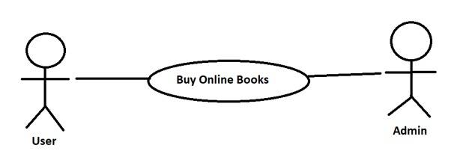

**Fig. 2.1 Access Home Page**

**Brief Description:**

User uses the **BuyOnlineBooks** system to access the home page.

Initial step-by-step description:

For this use case to be initiated, the user (student or admin) can use the online examination system.

1. The user connects to the system using a web browser.

2. The user selects the Home link on the website home page.

3. The system passes the user to the website Home Page.

**2.2.2b. Use Case: User Login or Signup**

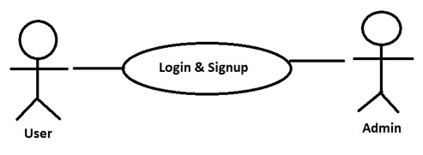

**Fig. 2.2 User Login or Signup**

**Brief Description**:

The user either logs in or signs up.

Initial step-by-step description:

For this use case to be initiated the user must be on the website Home Page.

1. The User selects the “Login” link.

2. If the user is already registered, he successfully gets logged in.

3. Else user has to sign up or register.

4. The BuyOnlineBook system returns the signup form.

5. The User fills the required details.

6. The User clicks submit.

7. The System retains information in the database.

8. The System returns the user to the website Home Page.

**2.2.2c. Use Case: Admin Create login/Upload /delete**

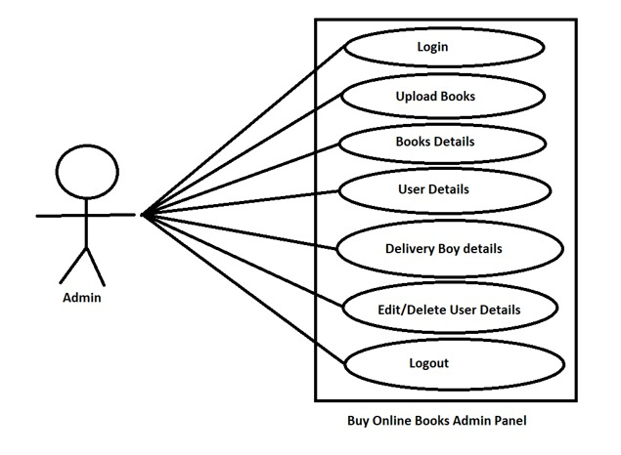

**Brief Description:**

The Admin chooses to create a login/Upload /delete book.

Initial step-by-step description:

For this use case to be initiated, the Admin must be logged infirst

1. The Admin selects the book which he wants to upload.

2. It can even delete any book .

3. It contains the user information such as name, contact no. , pincode, e-mail, password.

4. It also contains book details such as book name, book title, author’s name, publishers name, publication year, cover page of book, MRP, selling price, Image of book.

5. Delivery status that where the order is and by what date it will be delivered.

6. Addmin can edit or delete the user information.

**2.2.2d. Use Case: User choose Books, Purchase, sell/upload.**

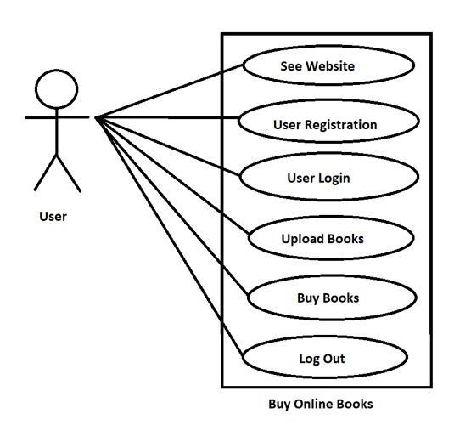

**Fig. 2.3 User see website /Register/Login/Upload/Buy/Logout**

**Brief Description**:

The user either logs in or signs up.

Initial step-by-step description:

For this use case to be initiated the user must be on the website Home Page.

1. The User selects the “book” link.

2. If the User is not logged in, he’s directed to login page. If he’s not a member, he has to sign up. Once User gets logged in, he may purchare or sell the book.

3. The User chooses a book.

4. The s User may add the books to cart to buy later on.

5. For purchasing book both online payment method and cash on delivery ( COD ) is available.

6. Once the book is beging purchased customer can check the delivery status.

***2.2.3. Non-functional requirements***

There are requirements that are not functional in nature. Specifically, these are the constraints the system must work within.

The web site must be compatible with Internet Explorer web browser.

**2.3. Requirement specifications**

***2.3.1. External interface specifications None***

***2.3.2. Functional Requirements***

**2.4. Hardware Specification**

***Client Side:***

* Internet Explorer: 6.0
* Processor: Pentium IV 2.0 and above.
* RAM : 8 GB
* Hard Disk : 1 TB

***Server Side:***

* Processor: Pentium IV 2.0 and above.
* RAM : 8 GB
* Disk space : 8GB

**2.5. Software Specification**

***Client Side:***

* html Framework
* Web Browser
* Windows 10

***Web Server:***

* Apache Xampp
* Windows 10

***Data Base Server:***

* *MySQL Server*

**2.6. Hardware and Software Requirements in detail**

**Hardware Requirements:**

* Processor: Pentium IV 2.0 and above.
* Internet Explorer: 6.0
* RAM : 8 GB
* Hard Disk : 1 TB
* Disk space : 8 GB

**Software Requirements:**

• **Apache Xampp (Cross-platform, Apache server, Mysql, PHP, Perl programming language.)**

* Xampp is a free and open-source cross-platform web server solution stack package developed by Apache Friends, consisting mainly of the Apache HTTP Server, MariaDB database, and interpreters for scripts written in the PHP and Perl programming languages.
* It runs on software such as windows , Linux , MacOS etc.

• **Client side languages**

* Html , css, javascript, bootstrap .
* Html is used to write code and create website using web pages.
* CSS and bootstrapping is used for designing the web pages.
* We have used cards from bootstrap 5 for showing the information about books.
* Bootstrap have the inbuilt properties and classes.

• **Server side scripting languages**

* Php, MySql.
  + PHP is an acronym for "PHP: Hypertext Preprocessor" PHP is a widely-used, open source scripting language. PHP scripts are executed on the server. PHP is free to download and use.
  + For php we have used sublime text (software) .
  + MySQL is a relational database management system (RDBMS) developed by Oracle that is based on structured query language (SQL). A database is a structured collection of data. It may be anything from a simple shopping list to a picture gallery or a place to hold the vast amounts of information in a corporate network.
  + We have used fatch , update, delete quarry .

***CHAPTER – III***

***SYSTEM ANALYSIS AND DESIGN***

**System Analysis and Design**

System analysis and design deal with planning the development of information systems through understanding and specifying in detail what a system should do and how the components of the system should be implemented and work together.

**3.1.Study & Weaknesses of Current System Current System**

**Current System**

The Current system of BuyOnlineBooks is easy and cheap. It is accessible to everyone.

There are various points that needs to be followed:

* Admin Login details
* User Login details
* User Registration details
* Uploaded Book Details
* Deleted book details
* Sold book details

**Weaknesses in Current System**

This system lacks some points.

* User can read any book without registration .
* Writer’s cannot use this website as a platform to post there articles, poems, or various other write-ups to enhance there skill and show there talent to the world.
* It doesn’t contain any news letters, magazine , or e-newspaper.
* This website doesn’t directly deny the cursed books .
* Cannot create wishlist.

**3.2. Requirements of New System**

***3.2.1. User Requirements***

The User requirements for the new system are to make the system fast, flexible, less prone to errors and save time.

* Time can be reduced by fast and quick response .
* A system that can automate the checking of cursed books.
* The New system should be more secure in managing user records and reliable enough to be used in any condition.
* Finally, it should prove cost effective as compared to the current system.

**3.3. Feasibility Study**

A key part of the preliminary investigation that reviews anticipated costs and benefits and recommends a course of action based on operational, technical, economic, and time factors. The purpose of the study is to determine if the systems request should proceed further.

***3.3.1. Does the New System Contribute to the Overall Objectives?***

The new system would contribute to the overall objectives. It would provide a quick, error free and cost effective solution to the current process. It would provide a solution to many issues in the current system. As the new system is flexible and scalable it can also be upgraded and extended to meet other complex requirements which may be raised in the future. However it is up to the User or Admin or creator

to upgrade or extend it.

***3.3.2. Can the New System be Implemented Using Current Technology?***

The system is connected by Internet LAN and managed by a server. It would be very easy to set up the system in the current environment as the application is web based it does not require to be installed on every machine. The database and IIS are set up on the server and the Html Framework installed on every machine, the system can be started as quick as required by the management.

**3.4. Features of the New System.**

The new system has been designed as per the user or customer requirements so as to fulfill almost all them.

* ***Easy to Store and Retrieve Information***

The new system makes it easy to store and retrieve information as required and does not involve storing information in separately . It thus saves data management problems faced in the current system as it has a Database Management System of its own .

* ***Cost Effective***

One of the main reasons of the new system is its cost effectiveness. It saves the amount spend on various things.

* ***Time Effective***

Customer need not to go out and search for the required book on various or different-different book stores.

* ***User profile***

User can see his own profile.

**3.5. Data Flow Diagram (DFD)**

The DFD (also known as bubble chart) is a simple graphical formalism that can be used to represent a system in terms of the input data into the system, various processes carried on these data, and the output data generated by the system. The main reason why the DFD technique is so popular is because the fact that the DFD is a very simple formalism – it is simple to understand and use. A DFD model uses a very limited number of primitive symbols to represent the functions performed by a system and the data flow among the functions. Starting with a set of high-level functions that a system performs, a DFD model hierarchy represents various sub-functions.

**3.5.1. DFD of Buy Online Book System**

1. **Zero level DFD**

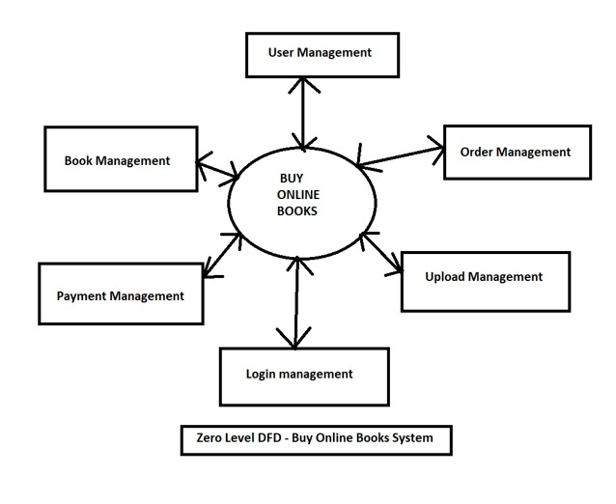

1. **Level 1 DFD**

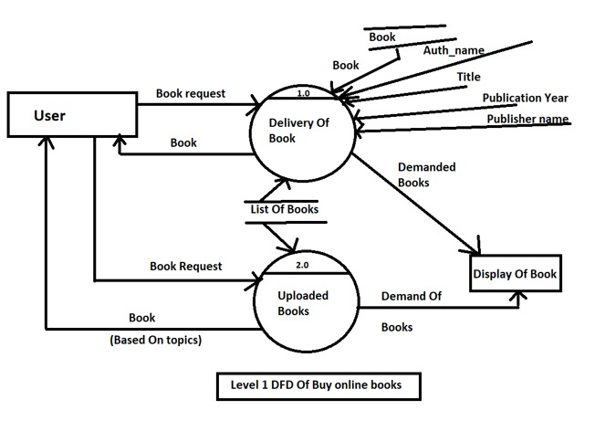

1. **Level 2 DFD**

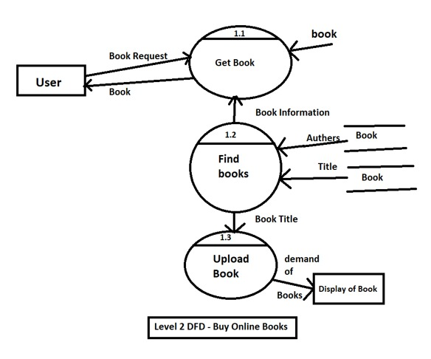

**3.6. UML Daigram**

UML is an acronym that stands for Unified Modeling Language. Simply put, UML is a modern approach to modeling and documenting software. In fact, it’s one of the most popular business process modeling techniques.

**3.6.1. Class diagram of Buy Online Book System**

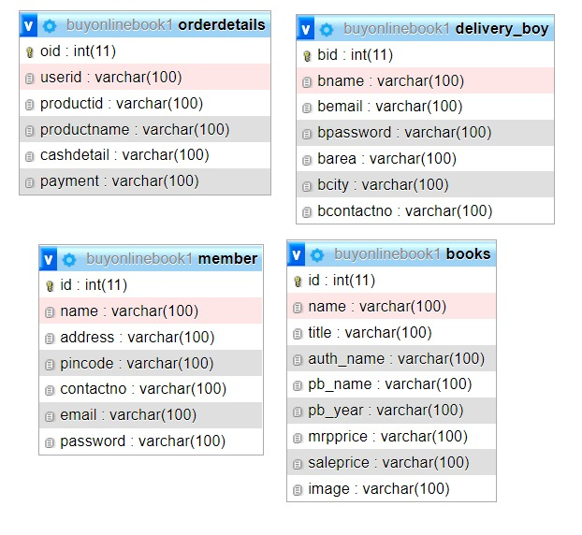

***CHAPTER – IV***

***DATA DICTIONARY***

**Data Dictionary**

A data dictionary is a catalog-a-repository of the elements in a system. As the name suggests, their elements center on data and the way they are structured to meet user requirements and organization needs. In a data dictionary you will find a list of all the elements composing the data flowing through a system. The major elements are data flows, data stores and processes.

The data dictionary stores details and descriptions of these elements. If analysis want to know characters are in a data item by what other names it is referenced in the system, or where it is referenced in the system, or where it is issued in the system, they should be able to find the answers in issued in the system, they should be able to find the answer in properly developed data dictionary.

The Dictionary contains two types of description for the data following through the system.

1. **Data Elements**

The most fundamental data is the elements. They are building blocks for all other data in the system. Data elements are also alternatively known as fields, data item or elementary item.

1. **Data Structure**

A data structure is a set if items that are related to one another and described a components in the system.

**4.1. Table Details**

**Table 4.1.1.AdminLogin**

|  |  |  |  |  |
| --- | --- | --- | --- | --- |
| **Field Name** | **Description** | **Constraints** | **Size** | **Data type** |
| Username | Unique username of the user |  | 50 | Varchar |
| Password | User password |  | 50 | Varchar |

**Table 4.1.2. Member table**

|  |  |  |  |  |
| --- | --- | --- | --- | --- |
| **Field Name** | **Description** | **Constraints** | **Size** | **Data type** |
| ID | ID of the user |  | 10 | Int |
| Name | Name of the user |  | 50 | Varchar |
| Address | Address of User |  | 50 | varchar |
| E-mail | E-mail address of user |  | 50 | varchar |
| Pincode | Pincode of user |  | 6 | int |
| Contact no. | Contact no. Of user |  | 20 | int |
| Password | User Password |  | 50 | varchar |

**Table 4.1.3. Book table**

|  |  |  |  |  |
| --- | --- | --- | --- | --- |
| **Field Name** | **Description** | **Constraints** | **Size** | **Data type** |
| ID | ID of book |  | 10 | Int |
| Name | Name of Book |  | 50 | Varchar |
| Title | Title of book |  | 50 | varchar |
| Author Name | Name of the author |  | 50 | Varchar |
| Publisher Name | Name of the publisher |  | 50 | Varchar |
| Publication year | Year of publication |  | 4 | int |
| MRP | Book mrp |  | 5 | int |
| Selling price | Selling price of the book |  | 5 | int |
| Image | Cover picture of the book |  | 200 mb | .jpg |

**Table 4.1.4. Delivery boy table**

|  |  |  |  |  |
| --- | --- | --- | --- | --- |
| **Field Name** | **Description** | **Constraints** | **Size** | **Data type** |
| ID | ID of the Delivery boy |  | 10 | Int |
| Name | Name of the Delivery boy |  | 50 | Varchar |
| E-mail | E-mail address of Delivery boy |  | 50 | varchar |
| Password | Delivery boy Password |  | 50 | varchar |
| Area |  |  |  |  |
| City | City of the Delivery boy |  | 50 | varchar |
| Contact no. | Contact no. Of Delivery boy |  | 20 | int |

**4.2. ER diagram of Buy Online Book System**

An entity–relationship model describes interrelated things of interest in a specific

domain of knowledge. A basic ER model is composed of entity types and specifies

relationships that can exist between entities.

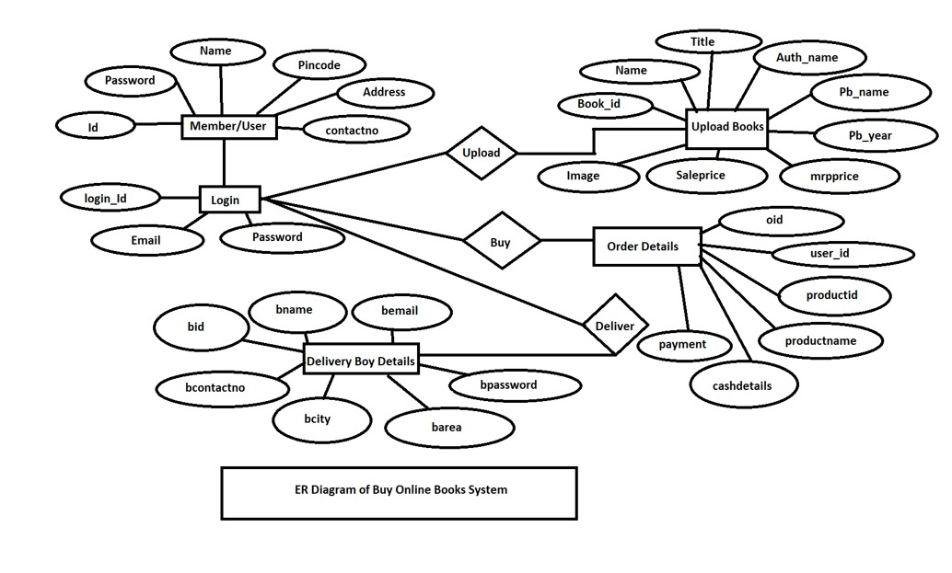

***CHAPTER – V***

***SCREENSHOTS***

**5.1. User panel**

**5.1.1. Index Page**

Index page is visible to all that is weather the user is registered or not. It is also known as Home Page.

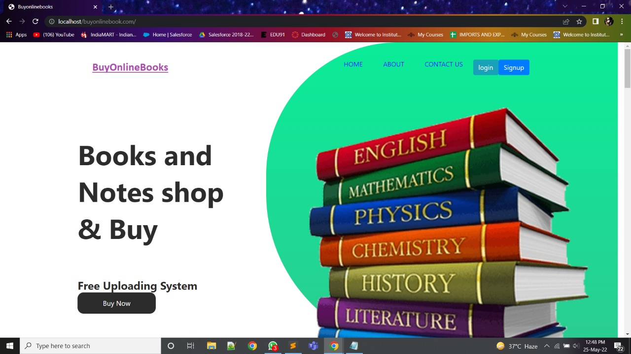

**5.1.2. About Ourself**

This page contains the details of the website and details of the person who created this particular wesite.

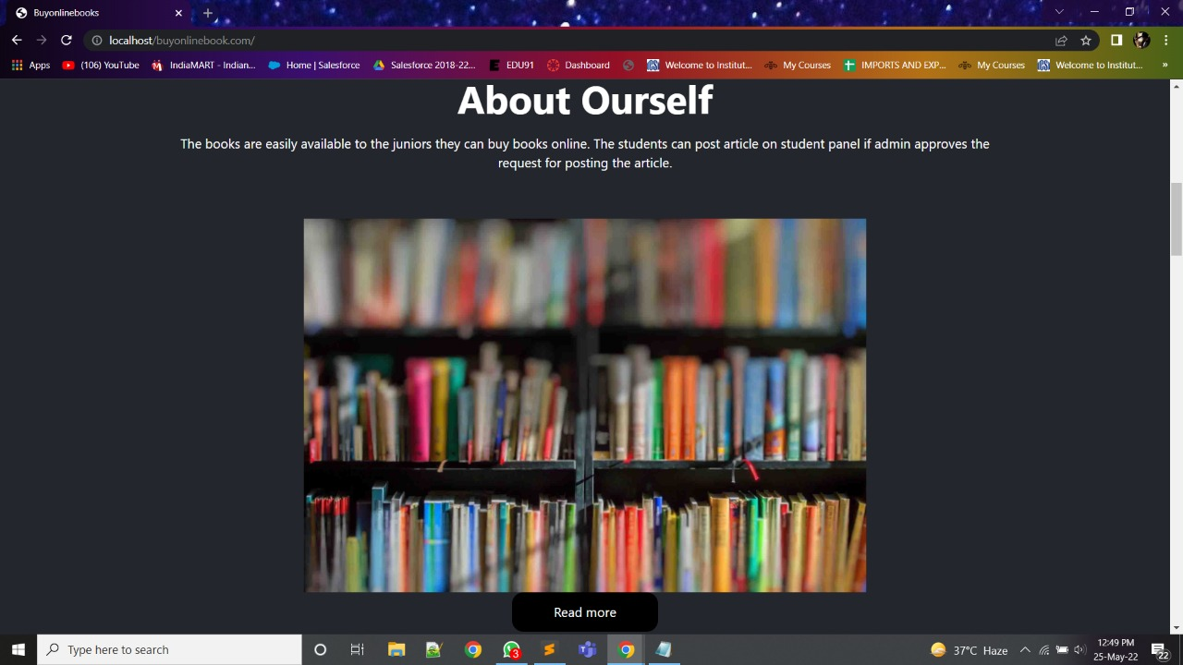

**5.1.3. User registration**

User can register here for purchase and sell of any book.

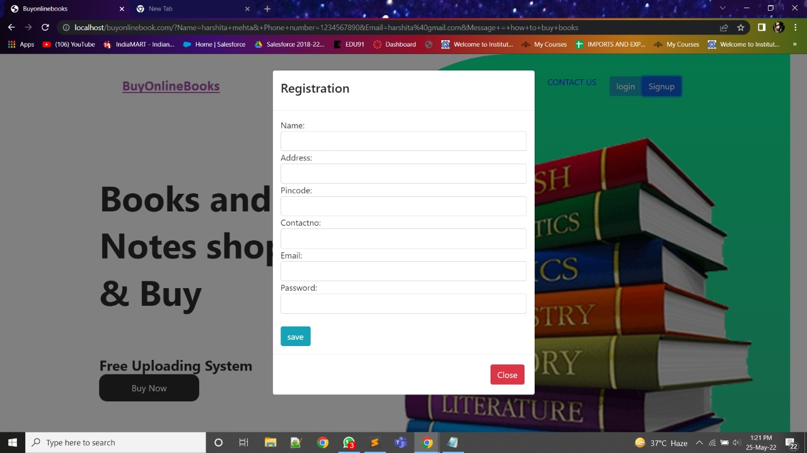

**5.1.4. Request a call back**

This page is created for the users quarry request. If a user have any quarry can post here and then wait for the solution response i.e., for the call back.

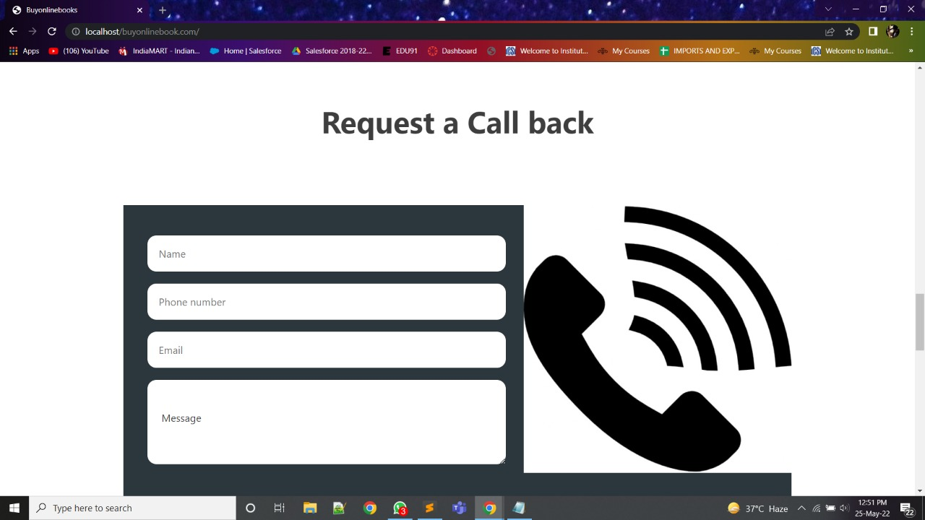

**5.1.5. Login page**

After registration person needs to login. Model is used here.

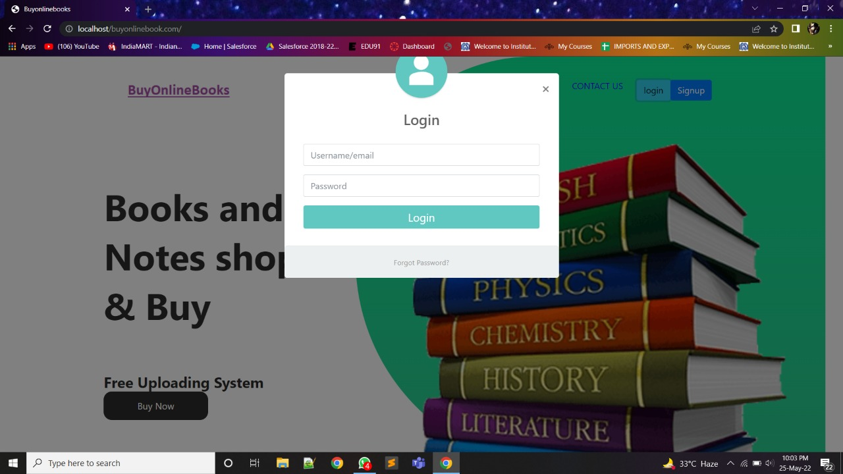

**5.1.6. Home page**

It appears to the user after he has successfully logged in.



**5.1.7. Navigation list**

This is prepared for the ease of user. List contains profile, edit, reset password, product details, upload books, delivery boy registration, logout.

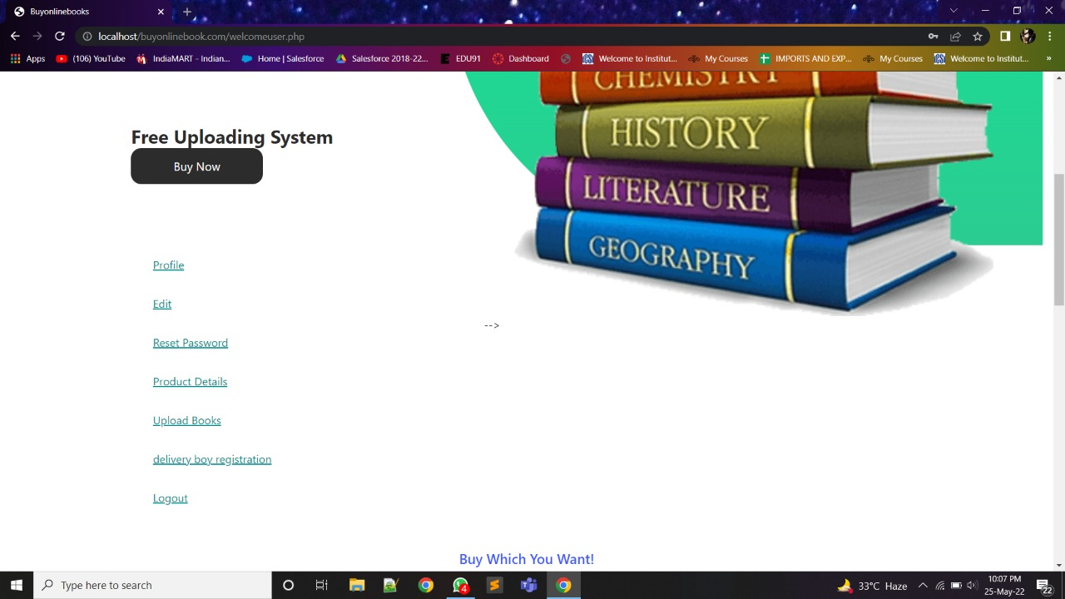

**5.1.8. User profile**

Here the details of user will be visible which the user has entered while registration which cannot be changed.

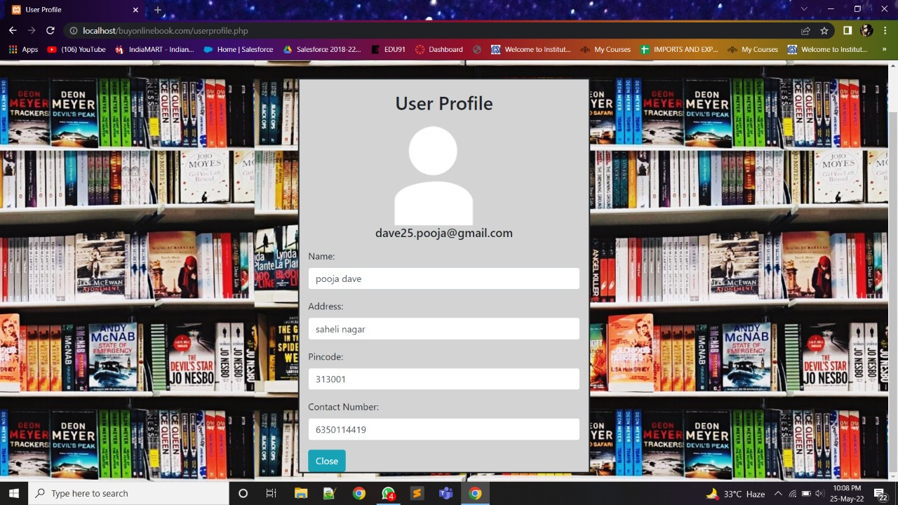

**5.1.9. Edit profile**

User can update his registered information.

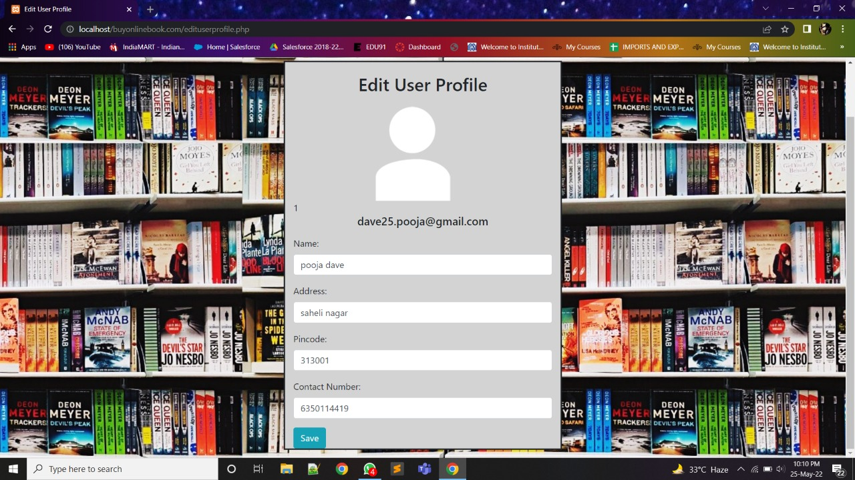

**5.1.10. Change password**

User can change or update his password.

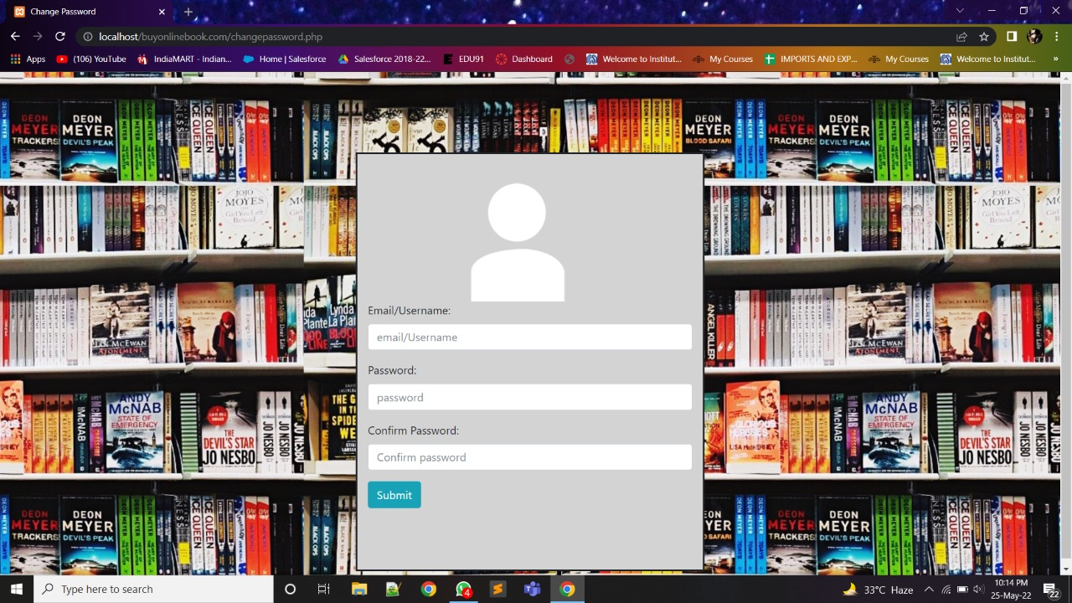

**5.1.11. Book uploading page**

Here the user uploads the details of the book such as book name, book title, author’s name, publishers name, publication year, MRP, selling price, Image of book.

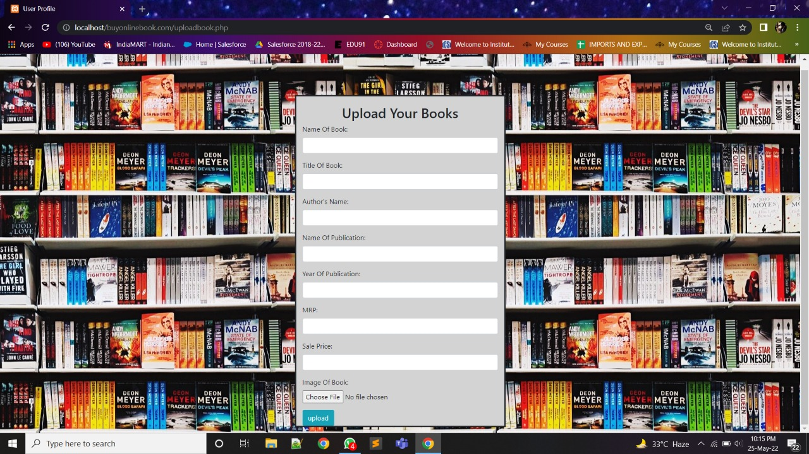

**5.1.12. Product detail page**

Here the details of the product appears purchased by the user.

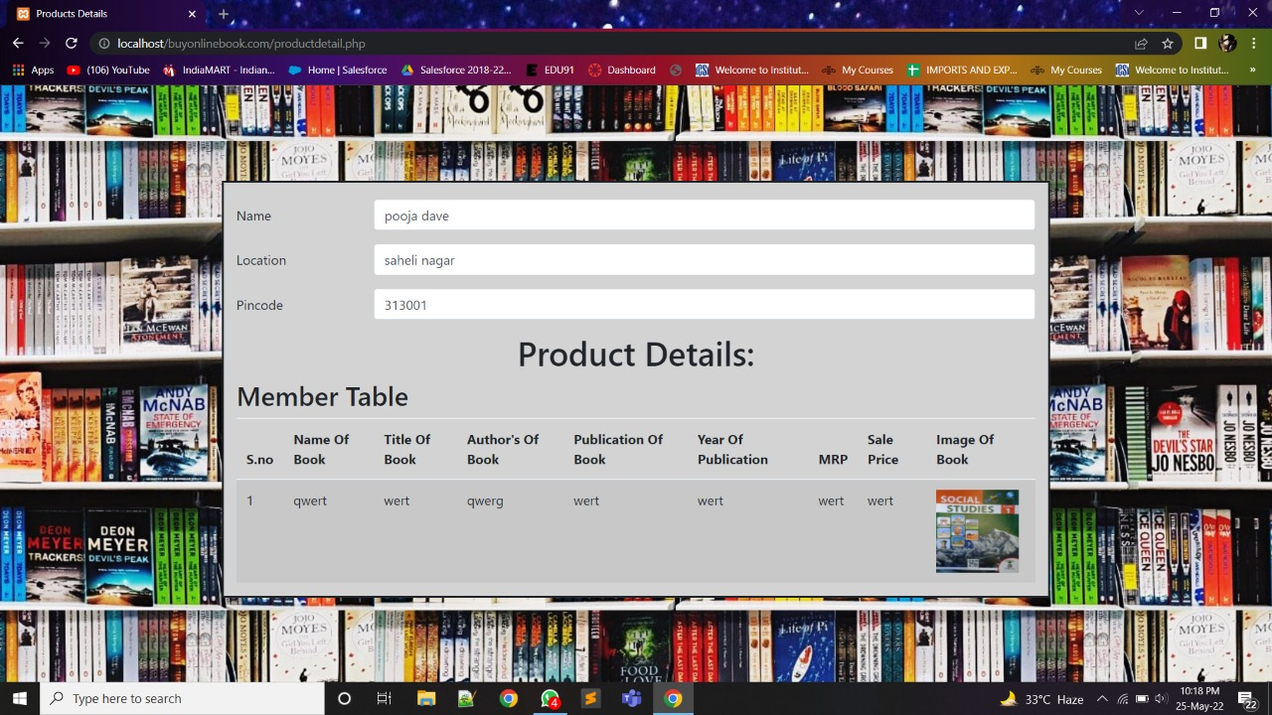

**5.1.13. Delivery boy registration**

Here the details of the delivery boy is present. This is visible and stored on the admin panel .

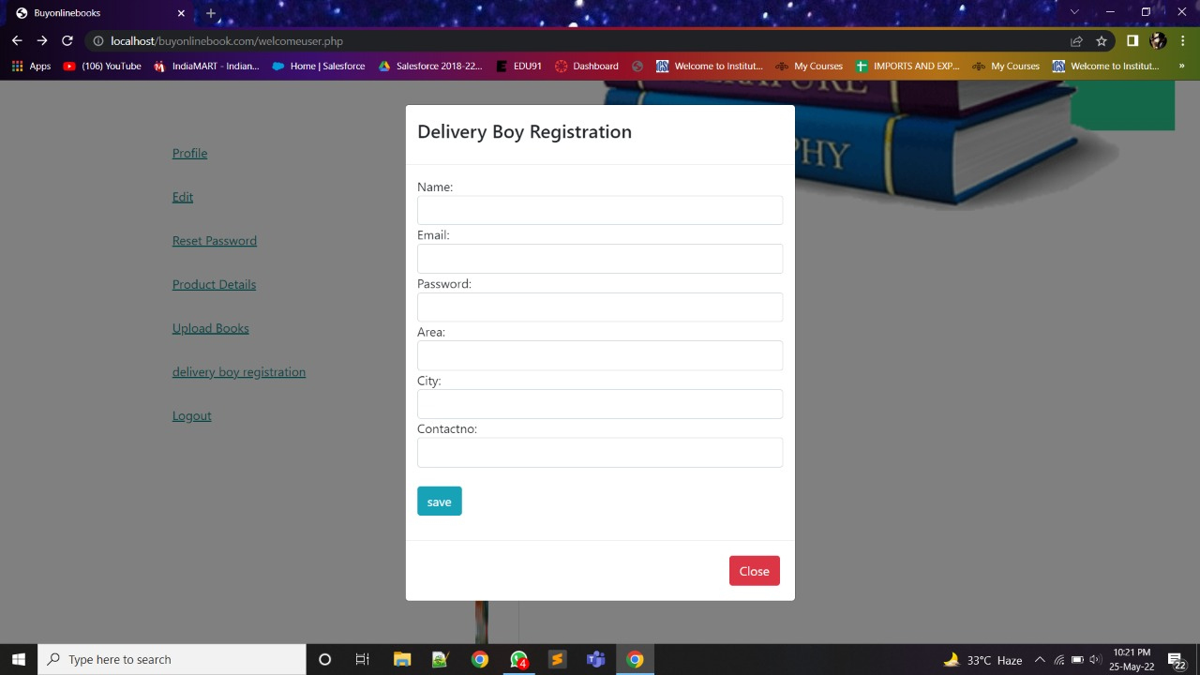

**5.1.14. Book cards**

1. These are the bootstrap cards (book cards). It contains the details and the image of the book.

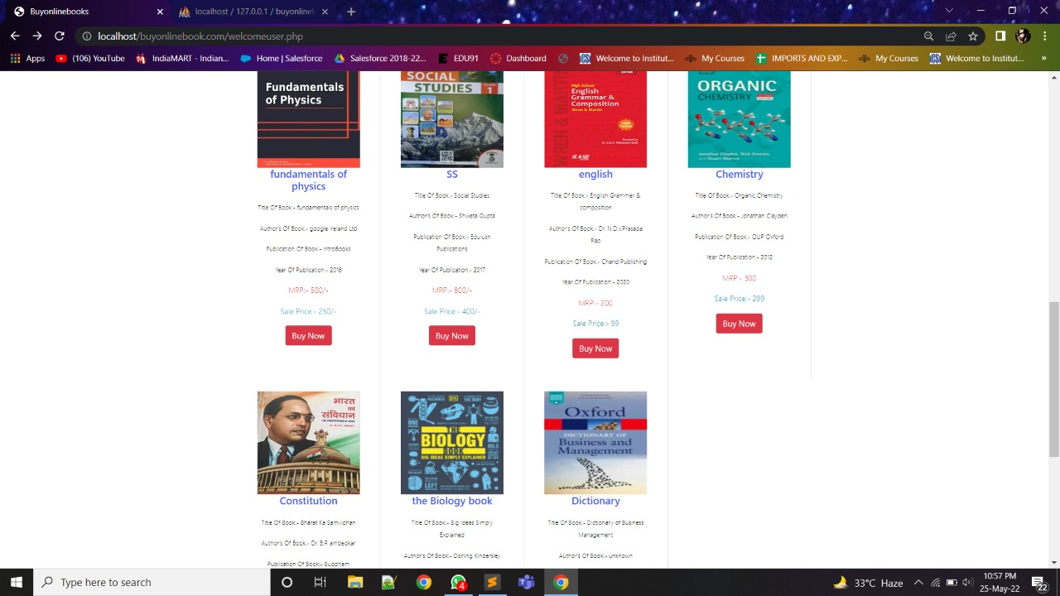

1. The user cannot purchase the books without registration.

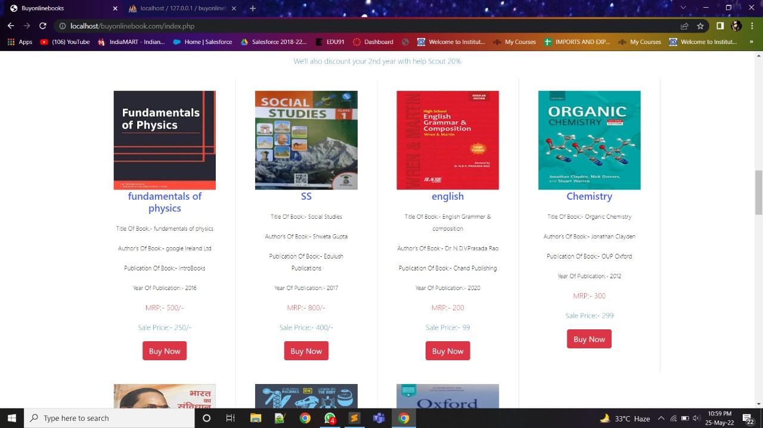

**5.1.15. Book details**

On clicking on buy now it shows the details of current selected book.

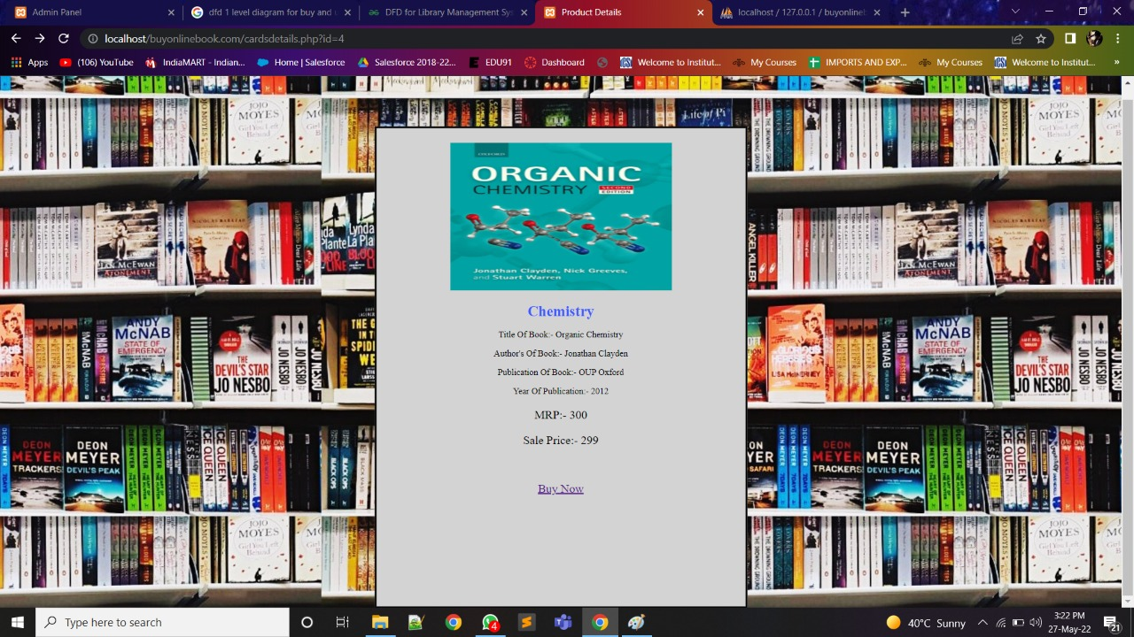

**5.1.16. Payment methods**

This page shows the payment methods i.e., online payment or cash on delivery (COD).

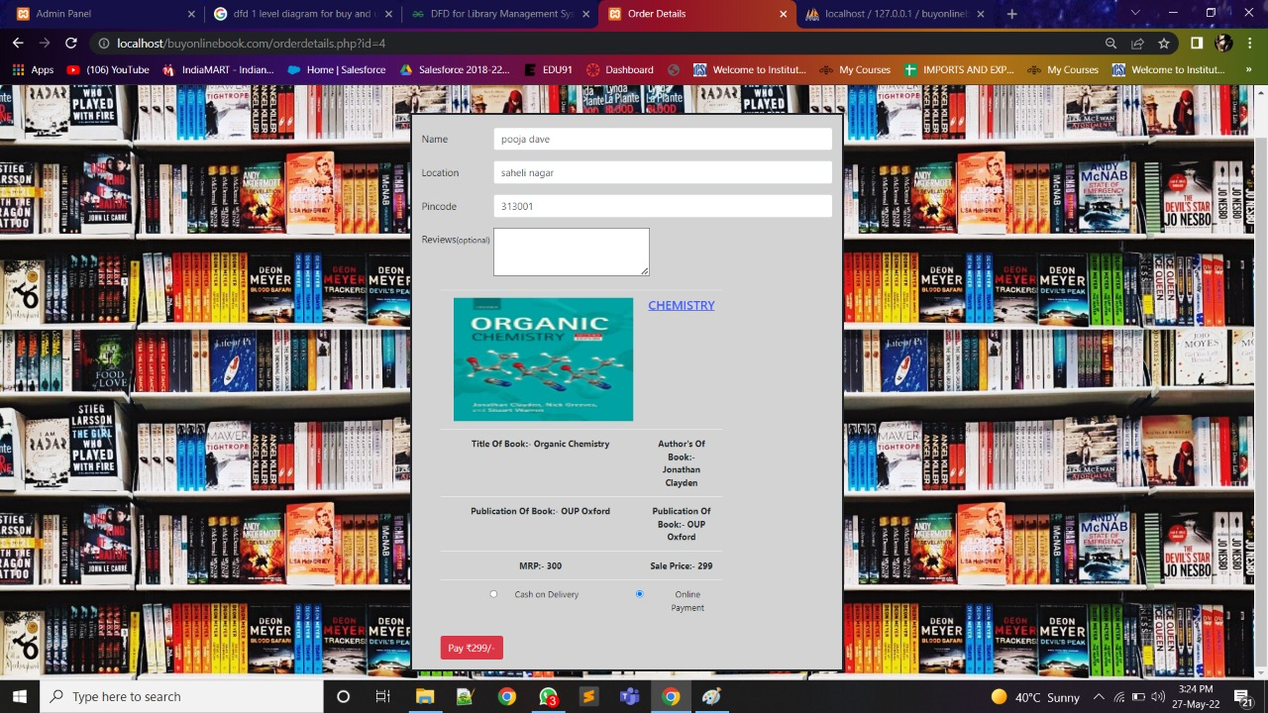

**5.1.17. Invoice**

This page will generate the bill of purchased books.

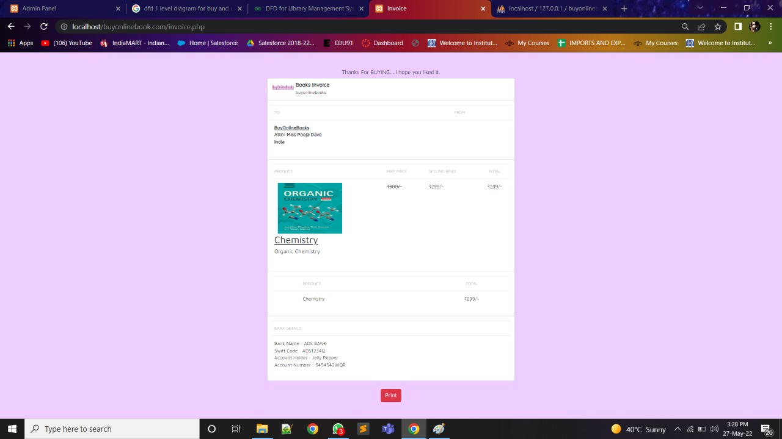

**5.2. Admin Panel**

**5.2.1. Admin login**

This is an admin login page.

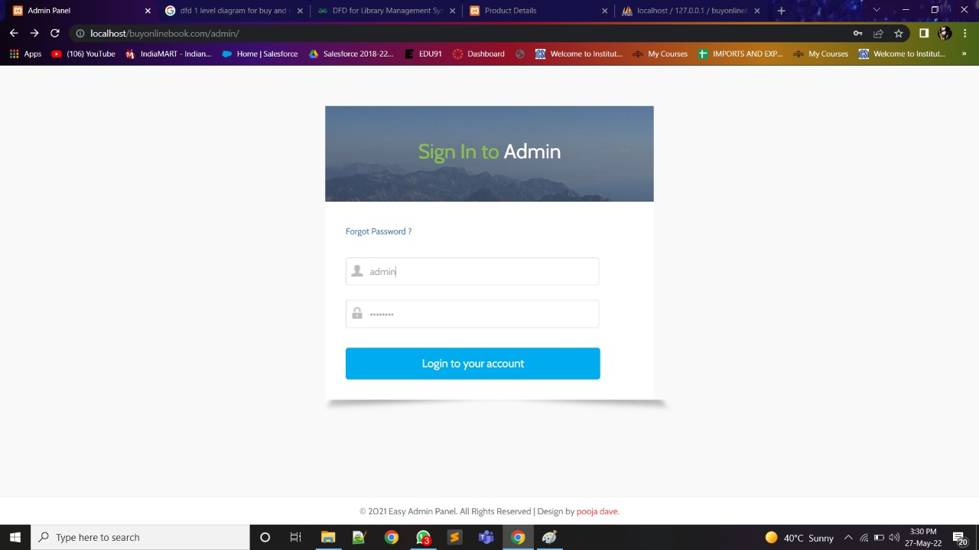

**5.2.2. Member detail**

This page contains the details of members which is visible to the admin.

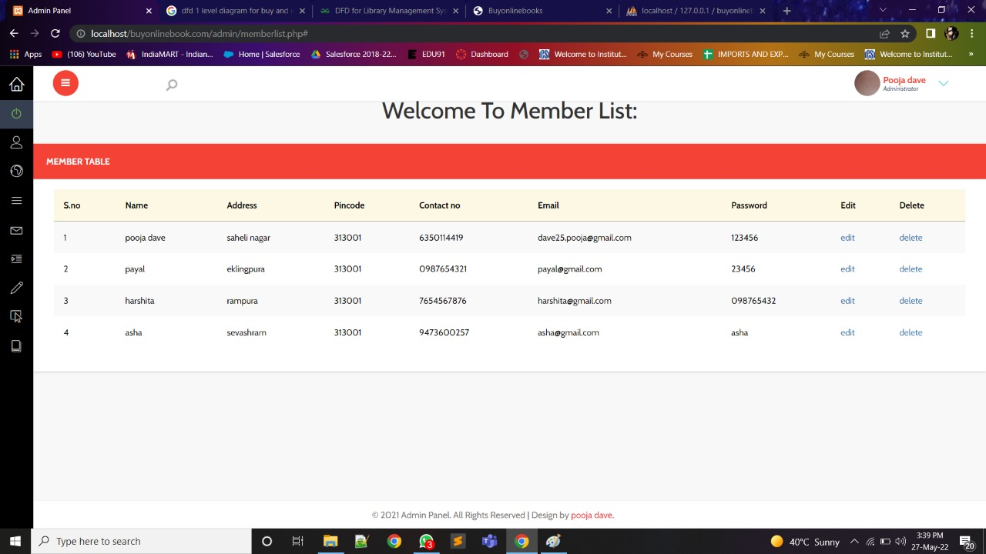

**5.2.3. Book uploading page**

Here the admin uploads the details of the book such as book name, book title, author’s name, publishers name, publication year, MRP, selling price, Image of book.

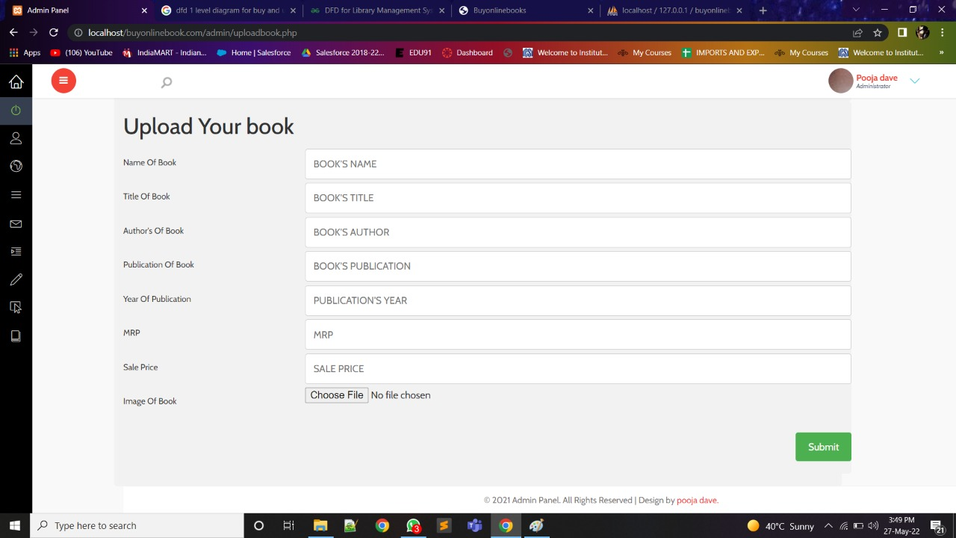

**5.2.4. Book list page**

This page contains the list of all the books present on the website.

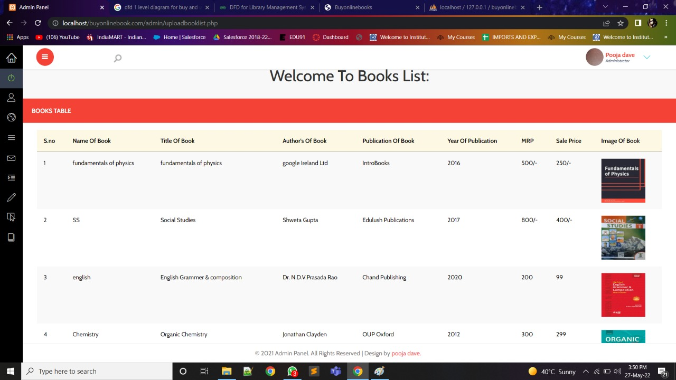

**5.2.5. Delivery boy details**

The admin can see the details or status of the delivery boy.

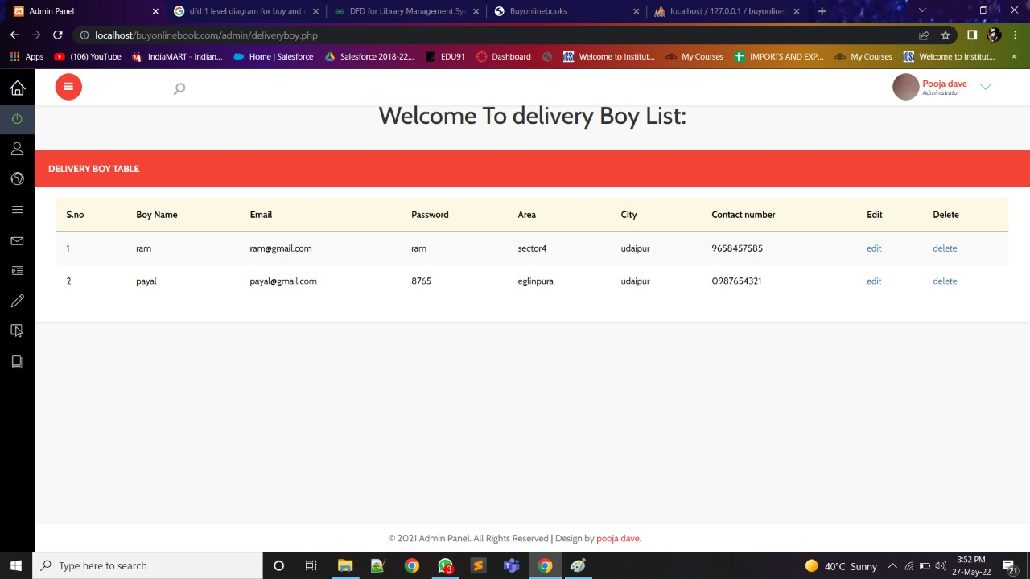

**5.3. Database**

**5.3.1. Member database**

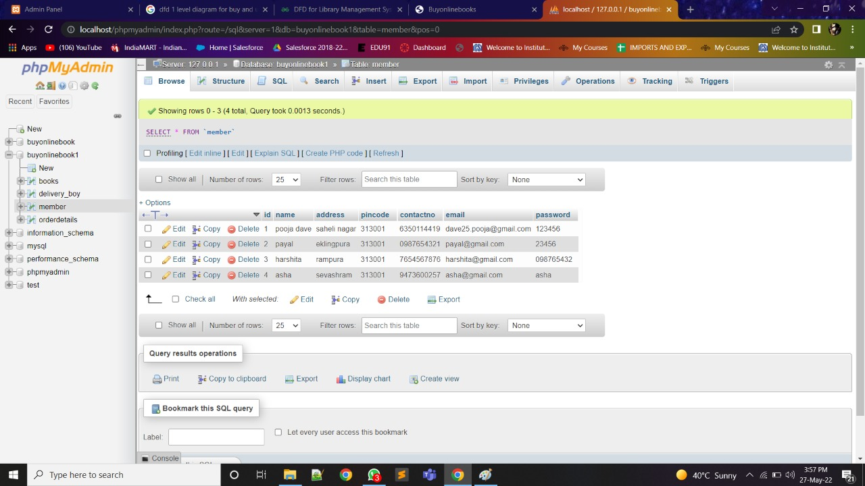

**5.3.2. Book database**

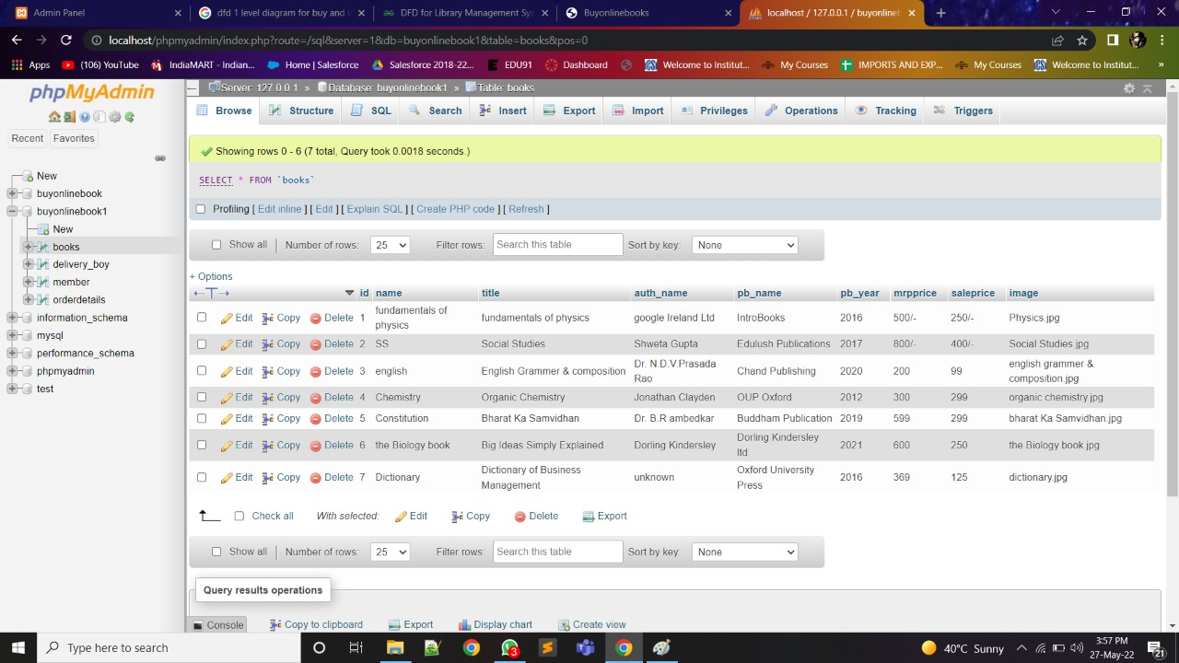

**5.3.3. Delivery boy database**

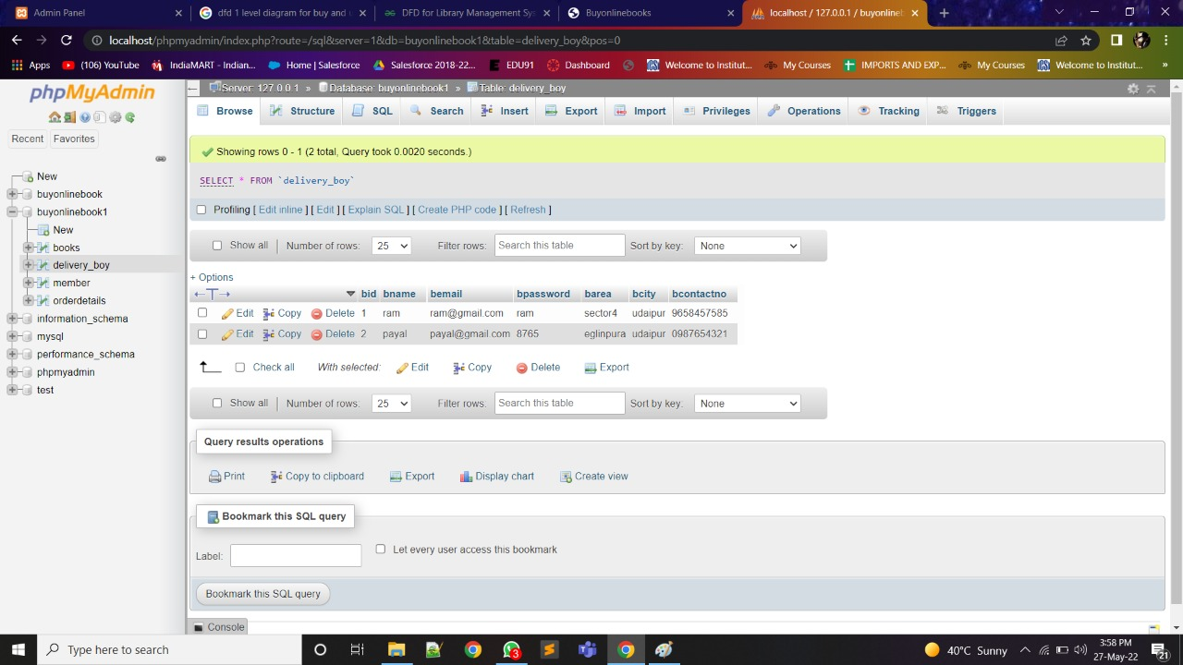

**CHAPTER – VI**

**CONCLUSION AND FUTURE ENHANCEMENT**

**Conclusion and Future Enhancement**

**7.1. Limitations**

The new system has been designed to meet almost all of the user requirements but it too has certain limitations some of which can be enhanced in the future enhancements or updates.

**7.2. Future Enhancement**

Software development is never –ending process and continues the life of the software per the changing needs of the user from time to time. The project is no doubt has been developed keeping in mind easy modification and enhancement that may be required from time to time. However, there are many scopes to modify this software. As because due to shortage often, we here become unable to include many things. We are trying to cover all their existing system for sales return records of the items but due to shortage of time we become unable to include many things. Due to lake of time I here include none of them and a future scope on can develop these returns which are so much essential. Only with a little more doing it is possible to design the formats for those returns. Moreover, an on-line system will be more helpful to the organization. . With almost the same data with only a little modification an on-line system can be designed to full fill their demands. All these can be considered to be futures cope for this project

**7.3. Conclusion**

The switch from written books being from bookstores to being ordered online or even just digital copies has had profound effects on the industry including bookstores and libraries and the general people of the world. The positives include easy access for everyone and cheaper books along with saving natural resources. The negatives however are much greater and cannot be ignored. Some of the negatives include the loss of jobs and businesses through the digitalization of books, the loom threat of Google books, as well as losing a sense of our past. Books have played such a large role in human history that it is bittersweet to be replacing them. To me, it seems that e-books, Google books, and online retailers are the future and that the future is good. But, if you look past all the conveniences and look at the people being affected by this then it becomes clear that this is not a future that I want.

***CHAPTER – VIII***

***BIBLIOGRAPHY***

**Bibliography**

List of useful Websites

1. <https://www.javatpoint.com/>
2. [www.w3schools.com](http://www.w3schools.com)
3. <https://www.programiz.com/>